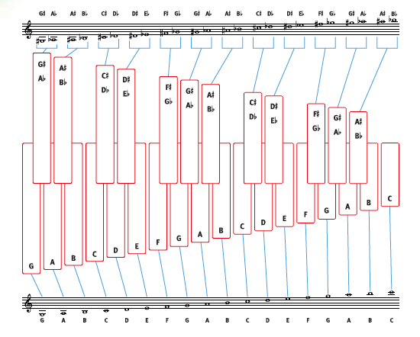

Mallet Percussion Keyboard Note Chart