Music Stores in Savannah
- Portman’s Music Superstore
Address: 7650 Abercorn St, Savannah, GA 31406
Phone: (912) 354-1500
Hours:
Friday | 10AM–8PM
Saturday | 10AM–8PM
Sunday | 1–5PM
Monday | 10AM–8PM
Tuesday | 10AM–8PM
Wednesday | 10AM–8PM
Thursday | 10AM–8PM

- Rody’s Music
Address: 311 Mall Blvd, Savannah, GA 31406
Phone: (912) 352-4666
Hours:
Friday | 10AM–6PM
Saturday | 10AM–6PM
Sunday | Closed
Monday | 10AM–6PM
Tuesday | 10AM–6PM
Wednesday | 10AM–6PM
Thursday | 10AM–6PM

- Musikhaus (Music House)
Address: 2424 Abercorn St, Savannah, GA 31401
Phone: (912) 358-0054
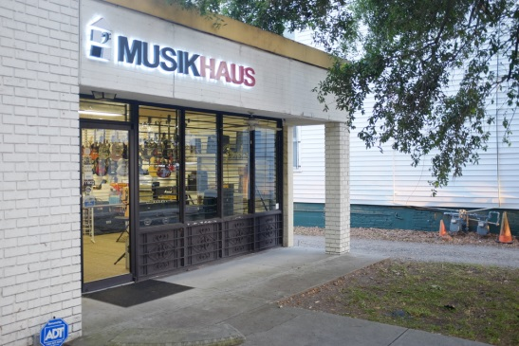
Hours:
Friday | 12–5:30PM
Saturday | 10:30AM–5PM
Sunday | Closed
Monday | Closed
Tuesday | 12–5:30PM
Wednesday | 12–5:30PM
Thursday | 12–5:30PM

